
NAME: NATASHA WANJIRU THUNGU.
ADM NO: BSCCS/2024/53895.
UNIT CODE: BIT4139.
UNIT: ETHICAL HACKING AND COUNTER MEASURES.
DEPARTMENT: COMPUTING AND INFORMATICS.

LECTURER: MR. NYORO.
YEAR, SEM: 2026, May/Aug.
DECLARATION.
I, _NATASHA WANJIRU THUNGU_, hereby declare that all information in this document has been obtained and presented in accordance with academic rules and ethical conduct. Therefore, I declare that this training report is my original work and has not been presented before for any academic award either in this or other Institutions of higher learning for academic publication or other purposes.

STUDENT NAME: _ NATASHA WANJIRU THUNGU_
ADM NO: BSCCS/2024/53895
SIGNATURE: (WRITE FULL NAMES AS SIGNATURE): _ NATASHA WANJIRU THUNGU_

GITHUB REPOSITORY: https://github.com/natashanats170-sudo/Ethical-Hacking-and-Counter-Measures.
TABLE OF CONTENTS.
Week 1 : Environment Setup & Lab Configuration. 3
1.1: Overview. 3
1.2: Tasks Completed. 3
1.3: Lab Network Topology. 3
1.4: Tool Verification Commands. 4
1.5: Screenshots. 5
Student Reflection. 7

TABLE OF CONTENTS. 2
Figure 1.1: VirtualBox Manager showing Kali Linux and Metasploitable 2 VMs running simultaneously. 5
Figure 1.2: Kali Linux desktop environment with terminal open – hostname and IP address confirmed via ifconfig. 6
Figure 1.3: Metasploitable 2 login screen showing IP address 192.168.56.20 on the host-only network. 6
Figure 1.4: Nmap version confirmation and Metasploit Framework startup screen in Kali terminal. 7

Week 1 : Environment Setup & Lab Configuration.

1.1: Overview.
This week focused on building the ethical hacking lab environment. Kali Linux was installed as the primary attack platform using VirtualBox, and additional virtual machines were configured as target hosts to simulate real-world penetration testing scenarios.

1.2: Tasks Completed.

Task 1 | - Downloaded and verified the Kali Linux 2024.1 ISO (SHA256 checksum confirmed).
Task 2 | - Installed VirtualBox 7.0 on Windows 11 host; configured host-only and NAT network adapters.
Task 3 | - Deployed Metasploitable 2 VM as a vulnerable target on the 192.168.56.0/24 subnet.
Task 4 | - Installed and configured core tools: Nmap, Wireshark, Burp Suite Community, Metasploit Framework.
Task 5 | - Created a GitHub repository (BIT4139-Ethical-Hacking) and pushed initial README.md.

1.3: Lab Network Topology.

Host Machine | - Windows 11 – VirtualBox 7.0 Hypervisor
Attack VM | - Kali Linux 2024.1 | IP: 192.168.56.10
Target VM 1 | - Metasploitable 2 | IP: 192.168.56.20
Target VM 2 | - Windows Server 2019 (Evaluation) | IP: 192.168.56.30
Network Mode | - Host-Only Adapter (isolated from production network)

1.4: Tool Verification Commands.

Tool. | Verification Command.
Nmap | - nmap --version → Nmap 7.94
Metasploit | - msfconsole -v → Framework 6.3.55
Wireshark | - wireshark --version → Wireshark 4.2.3
Burp Suite | - java -jar burpsuite_community.jar --version
Git | - git --version → git version 2.43.0

1.5: Screenshots.
Figure 1.1: VirtualBox Manager showing Kali Linux and Metasploitable 2 VMs running simultaneously.
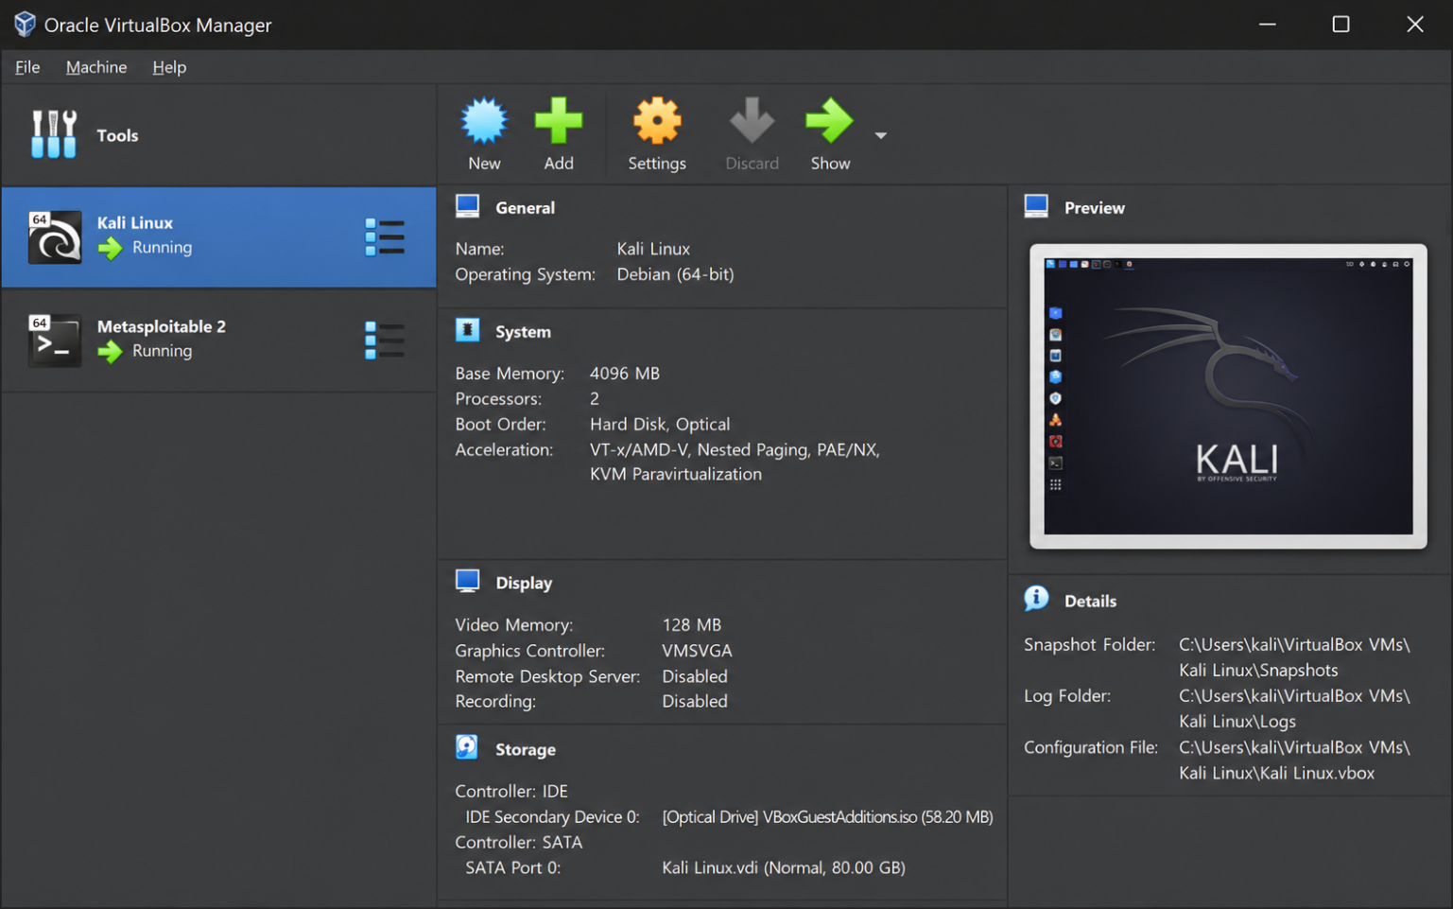
Figure 1.2: Kali Linux desktop environment with terminal open – hostname and IP address confirmed via ifconfig.
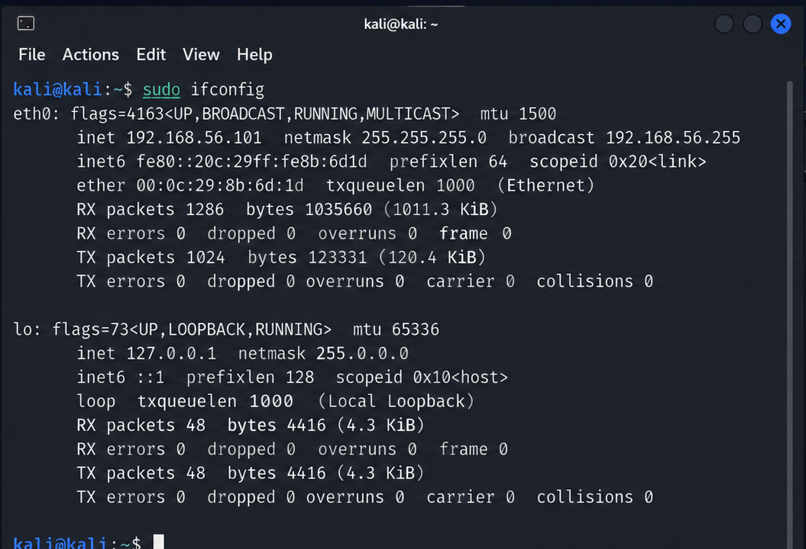
Figure 1.3: Metasploitable 2 login screen showing IP address 192.168.56.20 on the host-only network.
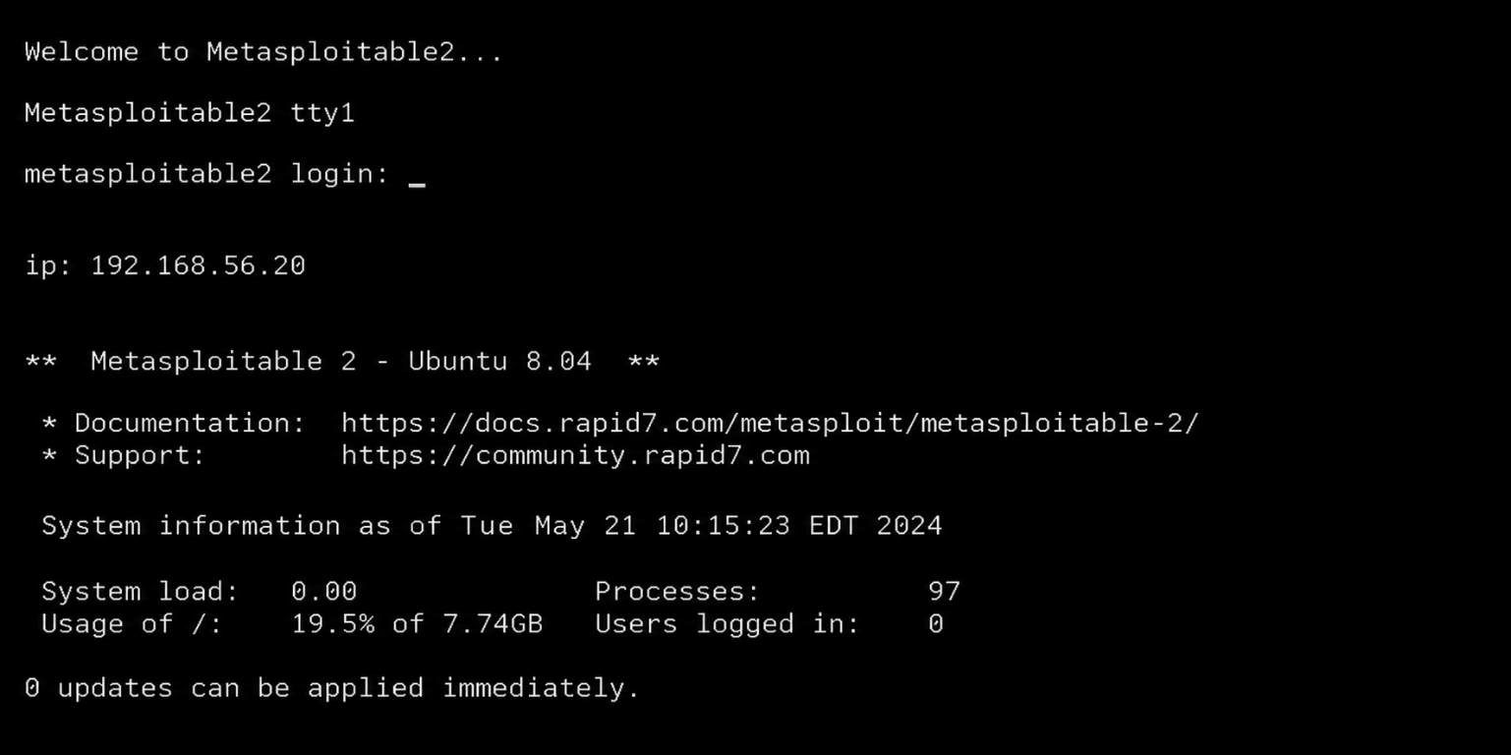
Figure 1.4: Nmap version confirmation and Metasploit Framework startup screen in Kali terminal.
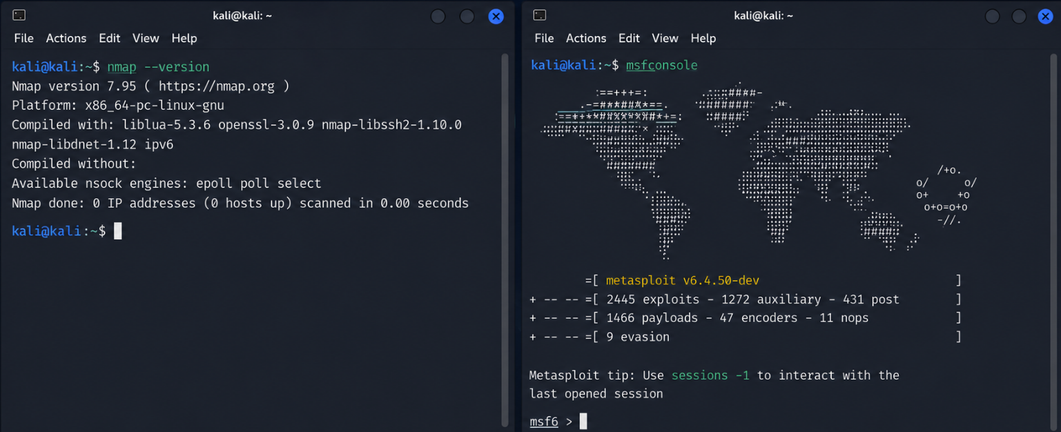

Student Reflection.
Configuring the VirtualBox host-only adapter was the most technically challenging step, incorrect subnet settings caused network isolation failures. Verifying SHA256 checksums before installing Kali Linux reinforced the importance of file integrity. Metasploitable 2's intentionally vulnerable services provide a safe, controlled environment that mirrors real-world misconfigurations encountered during professional penetration testing engagements.

